PERSONAL DATA

|  |  |
| --- | --- |
| **Name:** | Strazhevich Ivan |
| **Date of Birth:** | 11/06/1981 |
| **Location:** | Belarus, Minsk |
| **Mobile:** | +375 (29) 7554895 |
| **E-mail:** | vanechkas@gmail.com |
| **Skype:** | busiksky |
| **LinkedIn:** | [www.linkedin.com/in/ivan-strazhevich-658b54148/](http://www.linkedin.com/in/ivan-strazhevich-658b54148/) |

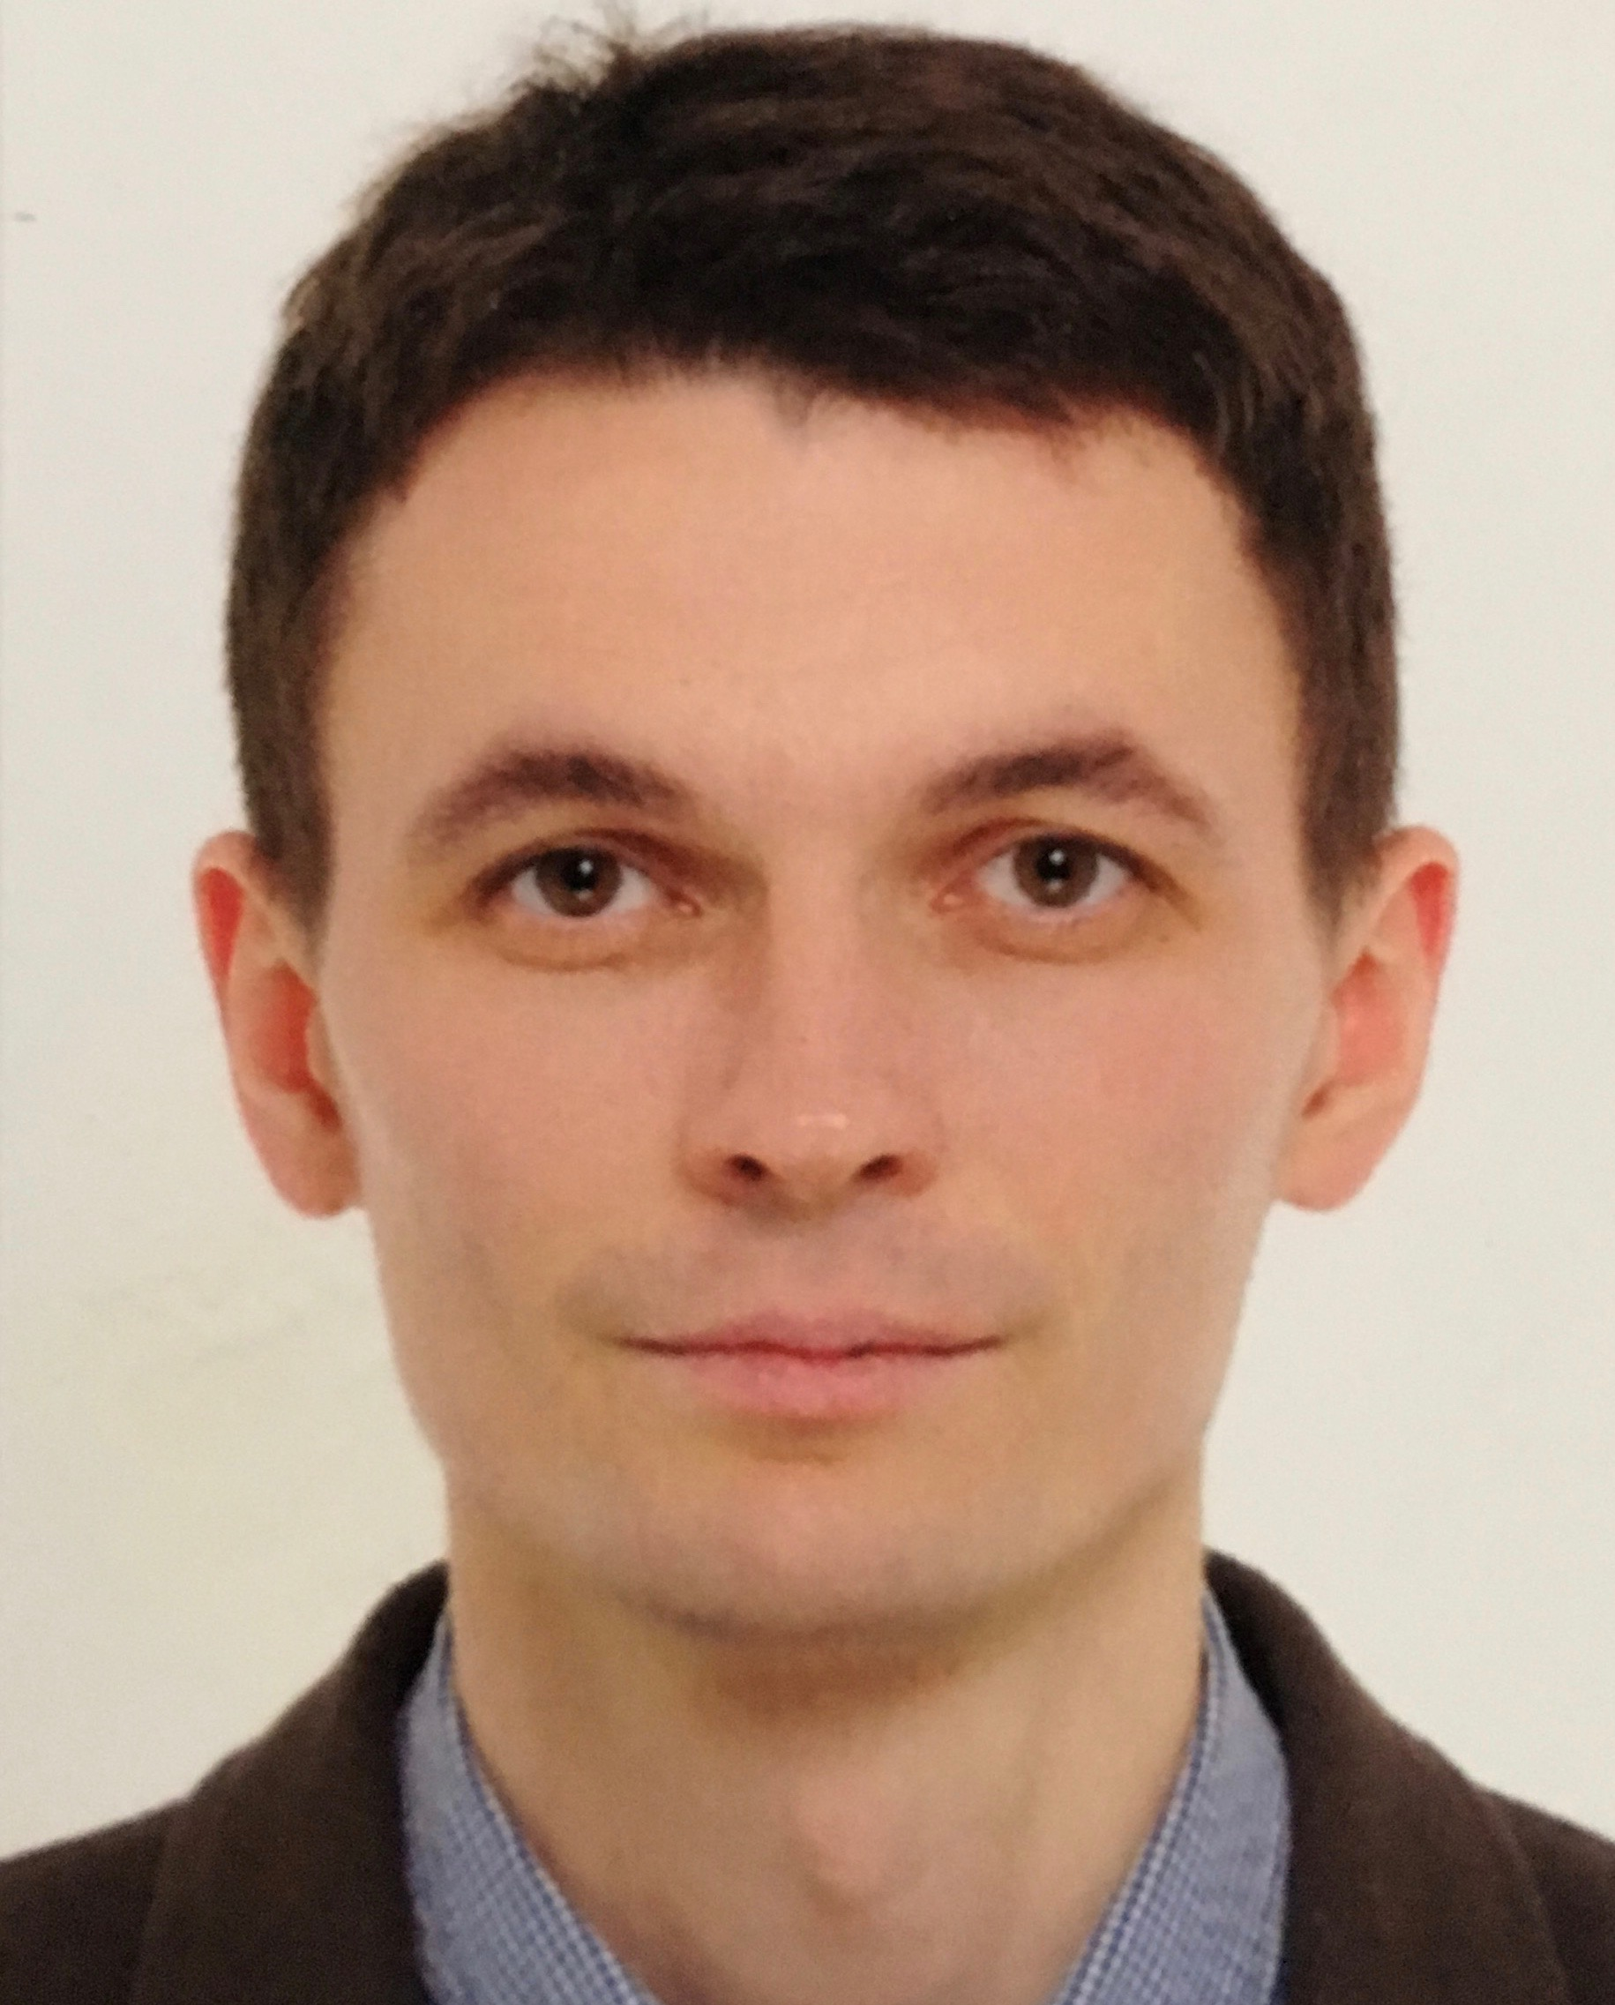

OBJECTIVE

|  |  |
| --- | --- |
| **Desired Position:** | Software Developer |
| **Desired Salary:** | Start from 400$ |

SUMMARY OF QUALIFICATION

|  |
| --- |
| I am working with Java platform starting from the **end of 2016**.  My current stack of technologies is:  **Java SE, EE, JSP, JSF, HTML5, Java Servlets, Spring Framework , EJB, Hibernate ORM, JPA, JDBC, MySQL, PostgreSQL, Git, Apache Maven, Apache Tomcat, Intellij IDEA**  I am working along with agilemethodologies including **Scrum**. |

TECHNICAL SKILLS

* Java SE, Java EE
* Spring, EJB
* MySQL, PostgreSQL, Hibernate, JPA Eclipcelink
* HTML5, JSP, JSF
* Git, Maven
* Junit, TestNG (bases)
* IntellijIDEA,

RELEVANT EXPERIENCE

* Small projects while studying and test project development.
* Participation at start-up PUSHka, as an intern Java developer. Console utility development
* LANGUAGES
* Russian – Native Speaker
* Belarussian – Native Speaker
* English – Pre Intermediate
* Italian -Bases

EDUCATION

* 2000-2005 / Belorussian institute of law/ Lawyer / Minsk, Belarus
* 1997-2000 / Belarusian college of business and law / Lawyer / Minsk, Belarus

OTHER INFORMATION

|  |
| --- |
| I am married and have a son, born on 2012. From 2000 I work as self-employe enterpreneur B2C and B2B sales BY->RU. On my free time I love to read, travel, skiing, snorkeling, biking, hiking. Pot some of my free time on self-education. Do yoga as professional hobby. Lead individual and group classes. |

COURSES AND CERTIFICATES

|  |  |  |  |  |  |  |
| --- | --- | --- | --- | --- | --- | --- |
| |  |  | | --- | --- | | **Course name:** | Java: from 0 to Job | | **Issued:** | ItStart.by (Pavel Veinik’s programming school) | | **Years of study:** | from November of 2016 to July of 2017 | |

|  |  |
| --- | --- |
| **E-learning assistant “PUSHka”** | |
| **Company:** | OOO “Obrazovatel'noye programmnoye obespecheniye” (Education software, Ltd.) |
| **Project Industry:** | E-learning, distance learning, MOOC |
| **Solution Web Site:** | [www.pushkaapp.com](http://www.pushkaapp.com) |
| **Business Location:** | Belarus |
| **Duration:** | 11/2017 – present time |
| **Project Description:** | The development of cross-platform solutions for choosing and planning of the distance learning. It includes the development of mechanisms for planning courses sites like “coursera.org” etc., a variety of the UI, the course catalog, a personal assistant. The solution for B2B and B2C sectors. |
| **Position:** | Java developer, intern |
| **Overall Team Size:** | 2 developers, 1 system architect, 1 QA engineer, 1 designer, 1 manager, 1 marketer |
| **Responsibilities:** | * Fetching data console utility development |
| **Tools & Technologies:** | **Platforms:**   * .NET * .NET Core * Azure   **Tools:**   * Visual Studio 2015 * TFS CI * TFS Git * Jira * Confluence * DevProm * Slack   **Languages & Technologies:**   * C# * MVC * Web API * Azure Web Jobs (console applications) * Microservice architect * Entity Framework * MSSQL * Dapper * AngularJS * Swagger * MS Bot Framework * Unity DILog4net * JavaEE * Hibernate * MySQL * JUnit |